EV DATA ANALYSIS REPORT

Dataset overview
EV sales dataset with 96,845 rows and 8 columns:
- Year
- Month_Name
- Date
- State
- Vehicle_Class
- Vehicle_Category
- Vehicle_Type
- EV_Sales_Quantity
It covers 2014 to 2023, 34 states/UTs, and vehicle groups like 2-Wheelers, 3-Wheelers, 4-Wheelers, Bus, Others.
Dataset summary

· Rows: 96,845
· Columns: 8
· States/UTs: 34
· Vehicle categories: 5
· Vehicle types: 12
· Time span: 2014 to Jan 2024
Important: 2024 looks partial, so full-year comparisons should mainly focus on 2014–2023.

Problem statement
How have EV sales grown across Indian states and vehicle segments from 2014 to 2024, and which regions, categories, and vehicle types are driving EV adoption the most?

Cleaning the data:

- Finding the null values:
df.isnull().sum()
Output:
>>> df.isnull().sum()
Year 0
Month_Name 0
Date 0
State 0
Vehicle_Class 0
Vehicle_Category 0
Vehicle_Type 0
EV_Sales_Quantity 0
dtype: int64

- Changing column names for easier analysis:
df.columns=df.columns.str.lower()
df.columns=df.columns.str.replace(' ','_')
Output:
Index(['year', 'month_name', 'date', 'state', 'vehicle_class',
'vehicle_category', 'vehicle_type', 'ev_sales_quantity'],
dtype='str')

Charts using python:
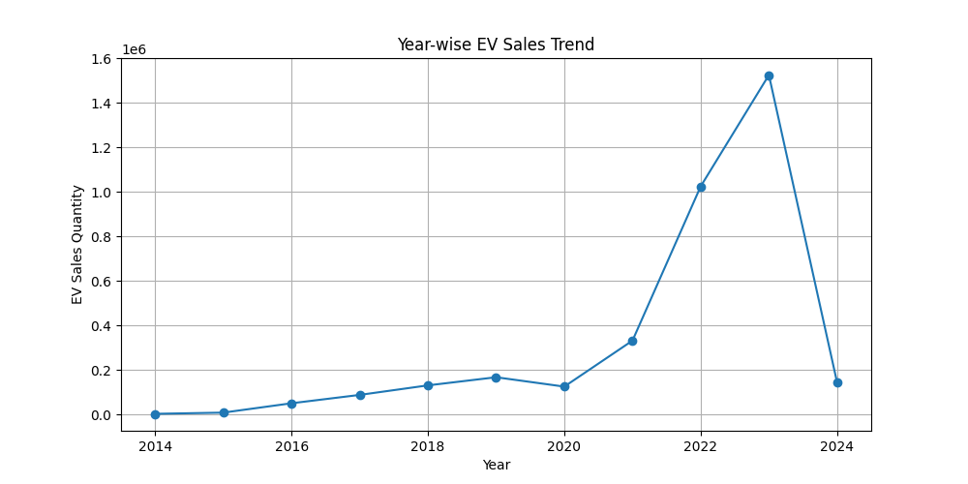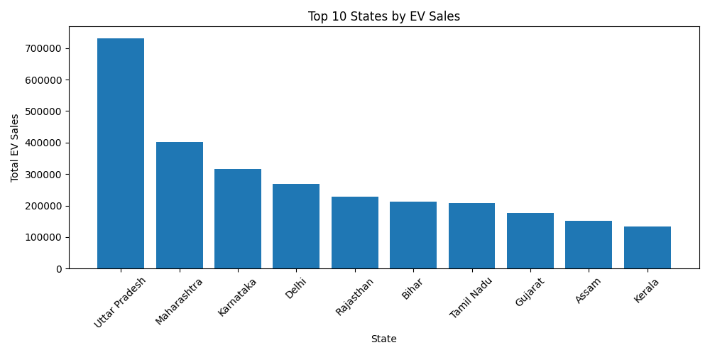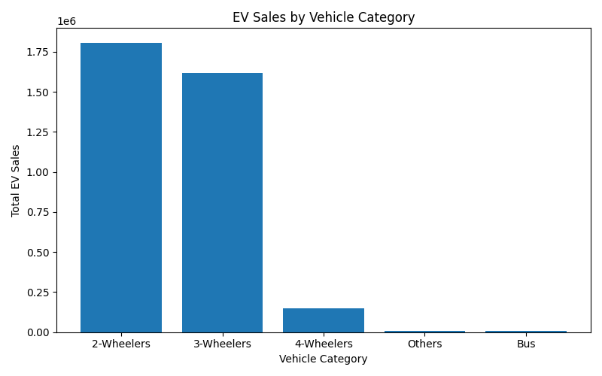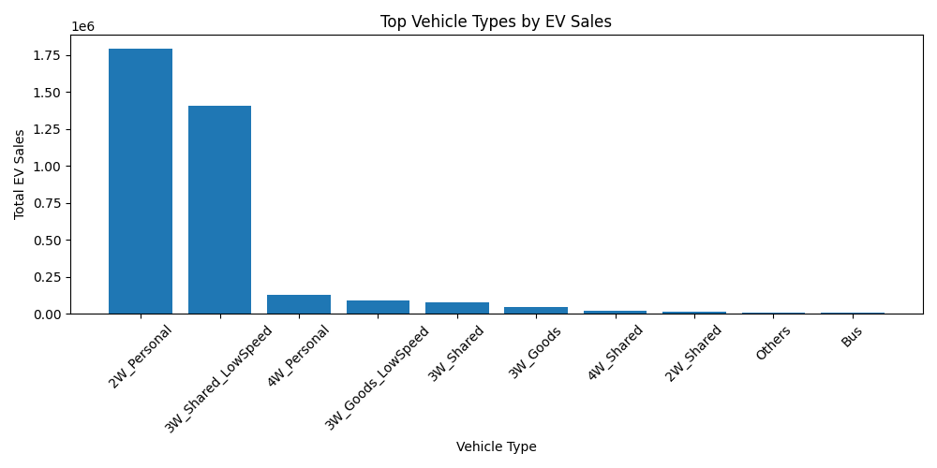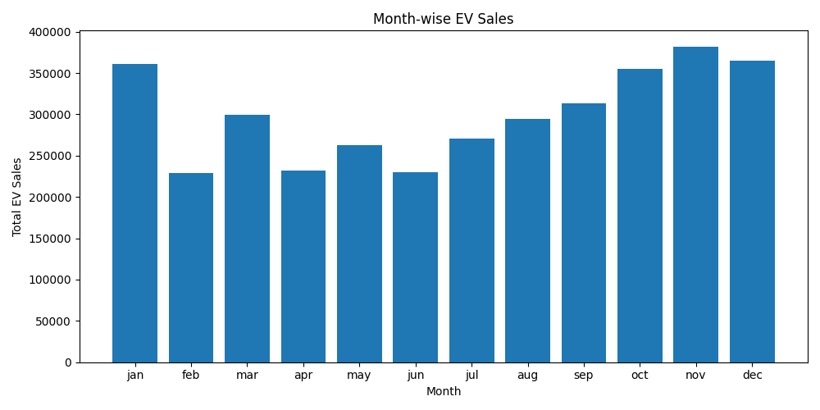

Analysis using SQL:
1. Which state has the highest EV sales overall?
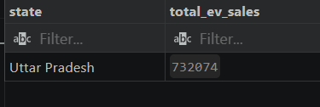

2.How have EV sales changed year by year from 2014 to 2023?
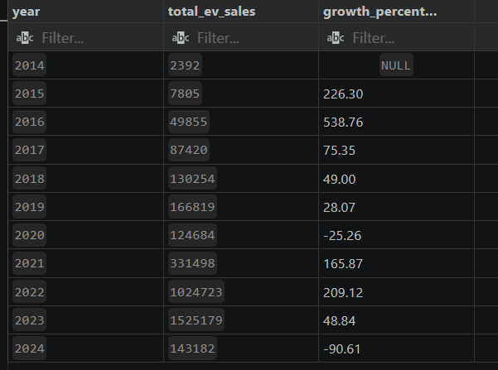
3.Which month shows the highest EV sales across the dataset?



4.Which vehicle category contributes the most to total EV sales?



5.Are 2-wheelers, 3-wheelers, 4-wheelers, or buses driving EV adoption the most?
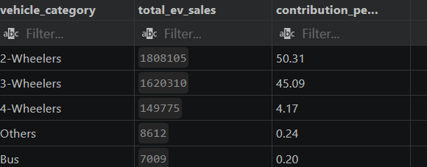

6.Which states show the fastest growth in EV sales over time?
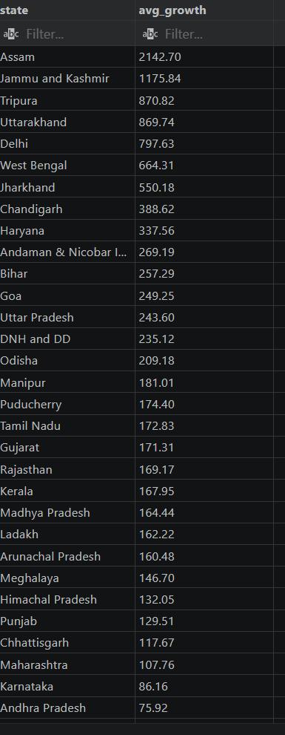

7.Which vehicle type is most common in each state?
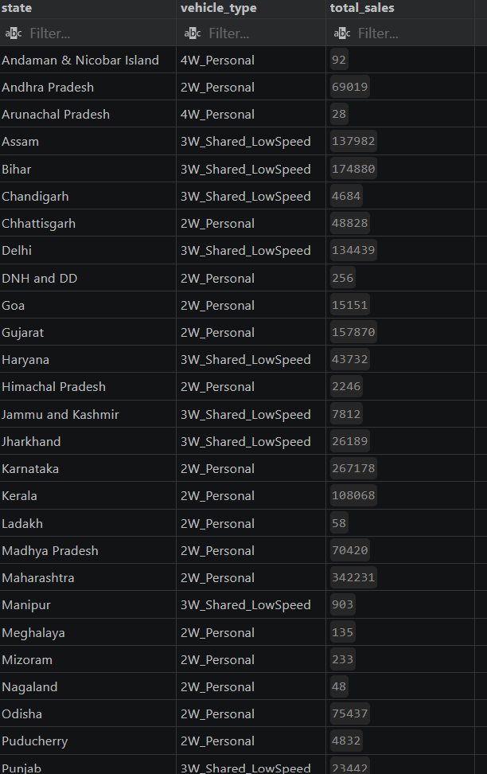

8.Is EV adoption concentrated in a few states or spread evenly across India?
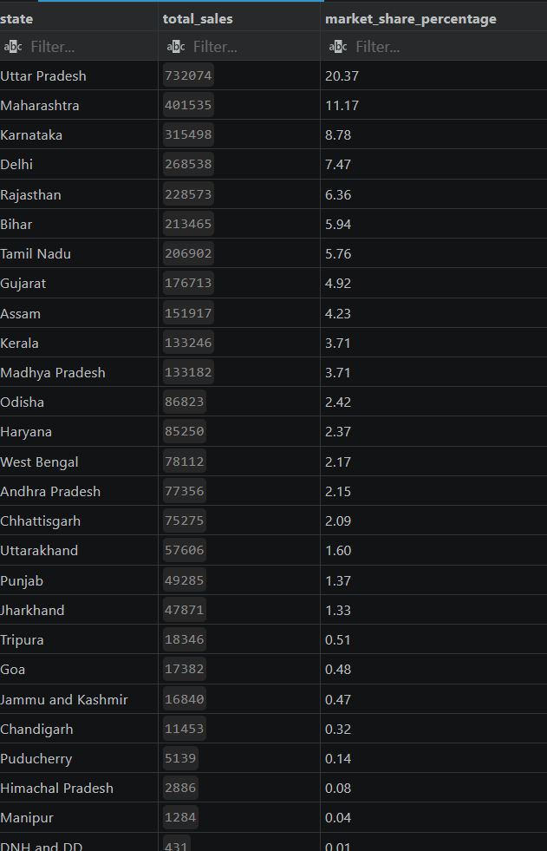

9.What is the trend of personal vs shared EV usage?
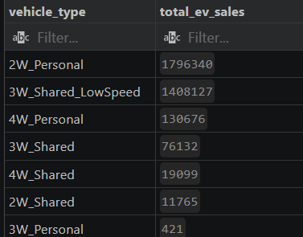

- Are there any seasonal spikes in EV sales for specific years or states?
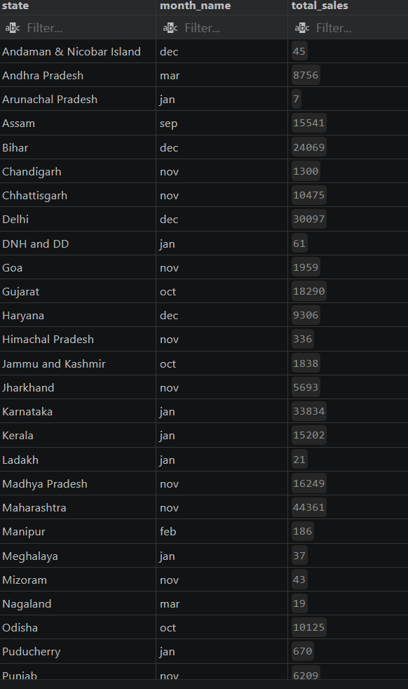
Power BI Dashboard:
